

A Project on
Tree Plantation
Management
Submitted by
Mr.Birari Om Shantaram
PRN: 2020015400050522

      Under Guidance of
Prof.Rupali Chavan

Bachelor of Computer Application
Faculty of Commerce and Management

Submitted to
Jaihind Educational Trust's
ZULAL BHILAJIRAO PATIL COLLEGE, DHULE

 Affiliated to 
Kavayitri Bahinabai Chaudhari North Maharashtra University, Jalgaon
Academic Year 2022-2023


CERTIFICATE
This is certify that Mr. Birari Om Shantaram Student of TYBCA (SEM-VI) has successfully completed the project entire on “Tree Plantation Management” for the Practical fulfilment Bachelor of Computer Application in Faculty of Commerce & Management of KBC’s North Maharashtra University, Jalgaon academic year 2023-24.Embodies the record of original work done by the under my supervision.

Date:
Place: Dhule

(Project Guide) (Head of Department)

________________ ________________

Internal Examiner External Examiner

Acknowledgement
I would like to thank Prof. Dr .P. H. Pawar sir the Principal of Jaihind Educational Trust's ZULAL BHILAJIRAO PATIL COLLEGE,DHULE for his precious suggestion, motivation and support in the project report.
I would like to thank Asst. Prof. P. G. Adawadkar sir, Head,Faculty of Commerce and Management for providing an opportunity to learn through project report work, by the medium of project. I consider myself to be fortunate to get this opportunity to explore in the project report of “Tree Plantation Management”. I am sincerely grateful to her for his valuable guidance, motivation and support at all stages of all project work, right from conception of idea to the finalization of project work and creating in a flexible and enjoyable environment to work.
I am thankful of Faculty of Commerce and Management for constant Inspiration in the pedagogical world of Bachelor of Computer Application.
Om Birari (TY.B.C.A.)

INDEX

Sr. No. | Content | Page No.
1 | Introduction to Organization | 5
2 | Existing System | 7
3 | Need Of Proposed System | 10
4 | Proposed System | 12
5 | Data Collection And Analysis | 13
6 | Hardware & Software Requirement | 14
7 | Feasibility Study | 16
8 | Database Design | 20
9 | Entity Relationship Diagram | 24
10 | Dataflow Diagram | 32
11 | Input Screen | 36
12 | Output Screen | 37
13 | Testing & Implementation | 38
14 | Suggestion & Conclusion | 39

CHAPTER-I
INTRODUCTION TO ORGANIZATION

Introduction About Organization:-
Name Of The Organization :- “Tree Plantation Management”.
Location :- Dhule
Proprietor :- Om Birari
The “Tree Plantation Management” Dhule. Is the well known NGO office. In this system daily working handled by manually. Following is this daily procedure of the system.
- The items are purchased from various Nursery. That means they are stocked in the . The purchasing is done on the basic of requirement of the Plantation.
- One Tree – One Life
- Who are We? - We are humanity/ non-profit/ fundraising/ NGO organization. Our humanity activities are taken place throughout globally, contribute with us by donating or be a part of the team, and encourage us to build great social community/green echo-system, again.
- Why are we here? - We aim to spread awareness about the social, environmental movement and to create an opportunity for everyone who is socially/environmentally accountable - so everyone shall come forward willingly to join our social program/environmental program.

Nomenclature
Plantation,prefers an accuracy and speed has developed a considerable impact aspects of our society. These are only some fields in which computer are only playing a role highly can aspects a vast increase in the range of the construction application and corresponding increases on the effect on construction will have one or daily lives.
Now a day the database system is a becoming important and widespread. All organization play very important role in human life relatively and considered as basic needs.
Plantation comes in picture when number of transaction increases due to the increase in number of organization. This automation for the Plantation in to keep up to date information of all system area / key area allow provides summary reports quickly accurate.
I expect from all user of this package that they have the basic of capability and important features of the garments system.

CHAPTER-II
PROPOSED & EXISTING SYSTEM

Existing system:-
The package is design for “EK RUKSH JIVNACHA,DUSANE” for maintain day to day transaction. Current system is manual.
Manual system:-
In “EK RUKSH JIVNACHA,DUSANE” the work of travel as per requirement is done manually. At the end of every day/month transaction are checked and maintain. Recording the owner of the organization will able to find following fact:-
1. Total Customer demand .
2. Total sales.
3. Balance towards the customer.
This will help determine the position of total work done.
Limitation of manual system:-
* Reporting is not made quickly because of time and cost
involved in manual system.
*Quick designing making is not possible as information regarding to particular medicines.
* Manual system is very time consuming
* Accuracy is very less.

Proposed system:-
Now a day, knowledge is the most important thing which increase the quantity of the person therefore every person should spend some time for reading. Because of it we can progress our talent and also get the satisfaction.
Hence, reading is the most important work of the human being’s life.
As the medical inventory system tackle with the information related to the medicines customer, as well as purchasing and selling the medicine.
So overall the process of handle the particular medicine in the stock as well as to maintain the record it take much more time. Hence to improve the quality of work as well as to processing I
have provided the Estimate Tree Plantation Management. This system throughout make a clear entries of the medicines and also maintains the regular transaction and stock of the EK RUKSH JIVNACHA,DUSANE . It also helps to improve within a fraction of seconds.
So in overall my system will help the management of take the proper decision about the medicine and its related transaction.
Any system must have objective or goal that are to be fulfilled by considering all the activities and man power relating to respective department of the concerned in order to reach the predefined plan and task.
Following are the objectives to fulfill by computerized Tree Plantation Management:-
1.Minimize the record through storage device.
2.Data can be easily access.
3.User friendly.
4.Less time required.
5.Data safely can be done by keeping the backup.
6.For assisting management reports are available in less time.
7.To take the proper decision for the management with the help of MIS reports.
So in all the processing, I think my system will work properly as per the requirement of the management of the “Tree Plantation Management”.

CHAPTER-III
 NEED OF COMPUTERIZATION

Need of computerization:-
Inventory management system is one of the major system which has get garment. In big inventory, number of members are handled. As the existing system is manual. It has some drawbacks such as time consuming, accuracy is less, can’t possible quick access particular records etc. to overcome these drawbacks garement is essential. This system is for members can easily managed by manual system as for such members no larger data maintains is required.
Advantages of computerization:-
a. Speed:-
The machine works with tremendous speed of searching a particular record, processing information, printing reports. Thus it saves “time”.
b. Accuracy:-
In manual system accuracy is low because of inability to process data and error committed due to more and repetitive task. Accurate results can be achieved using standard software. It is possible to be built in various type of error checking procedure to ensure that data entry is valid or correct.
c. Large storage capacity:-
It is possible to keep record on paper but this will need large storage area and then it is very tedious job to handle the data through papers. As computer saves the everything it protects the data from damage and keeps it for long time. Today’s computer have great super built memory system. The computer can store a great amount of information.

d. Security:-
As the data is stored on the magnetic device such as hard disk, floppy disk does not get damaged. This type of data can be viewed and part of data can be taken on the printers as and when required.

CHAPTER-IV
 PROJECT PROFILE

Project title:-
“Tree Plantation Management”
Aim :-
1.To maintain all the documentation of which is related to the volounter.
2.Prepare daily maintains of sales transaction and purchases.
Organization:-
“Plantation Management, Dhule (dusane)”.
Tool used:-
Hardware used :-
Software used :- VB.NET.2008
Back end :- MS ACCESS 2007
Front end :- VB.NET 2008
Operating system :- WINDOWS XP
Project guide :-
Developed by :- Om Birari

CHAPTER-V
 HARDWARE & SOFTWARE
As I am going to provide computrize inventory system to the organization. They have to deal with the following hardware and software.
Hardware Requirement:-
The organization will need the following minimum hardware requirement.
Processor :- Minimum Intel Core I 3 Or its equivalent processor.
RAM :- Minimum of 4 GB RAM
Backup drive :-Pen Drive
Hard drive :-Minimum of 1 TB
Monitor :-Minimum 14” Color Monitor.
Mouse :- A ps/2 or Serial Mouse.
Printer :- 80 Column Dot Matrix Printer.
Keyboard :- 105 Key Keyboard.
With above configuration my system will run fast, if higher configuration is available then it will be good.
Software requirements:-
Operating system :- Windows XP
Front end entry :- Visual Sudio 2008
Back end entry :- Ms-Access 2007

CHAPTER-VI
 FEASIBILITY STUDY

Feasibility study:-
Feasibility study is second stage in system development lifecycle feasibility study is a test of system proposal according to the availability of impact on organization ability to meet user needs and effective user of resources. Feasibility study involves:-
A. Economical feasibility.
B. Technical feasibility.
C. Behavioral feasibility.
Economical feasibility:-
Economical feasibility is the most frequently used method for evaluation of effectiveness of proposed system. Cost benefits and saving are determined from proposed system and compared with the cost.
The different type of cost to be considers:-
Manpower cost.
Hardware cost.
Operating cost.
Manpower cost:-
My proposed system can be communicated with the departments in the current system so that a single person can handle the work of overall system. No extra manpower is required.
Hardware cost:-
As per detailed provided in the section of hardware and software requirement I have provided the minimum hardware requirement to handle the system. It will not much more cost as per our manual system.
Operating cost:-
Commonly we does not require much more training to train the operator to compute the current system. So obviously it will reduce the operational cost in the form of training. Within a very few period time a normal user can himself strained in the system.

Technical feasibility :-
In technical feasibility study of function, performance and constrains that may affect the ability to achieve an acceptable system are considered. Technical feasibility centers around the existing computerized system and at what extends it can support the proposed system. In the proposed system if networking is required then it will support the system. To improve the efficiency and effectiveness the organization may adopt the new technologies will be applied in the proposed system.
C. Behavioral feasibility:-
Generally , people are inherently ton change to the computer system. But In case of my proposed system the users will easily adopt the system. Behavioral feasibility deals with how strong a reaction the user staff is likely to have towards the development of proposed computerized system.

CHAPTER-VII
 ABOUT ENVIRONMENT
Introduction to .NET environment:-
Visual Studio .NET is a complete set of development tools for building ASP web applications, XML web services, desktop application, mobile applications. Visual Basic .NET, Visual C++, & Visual C#.NET
All use the same integrated development environment (IDE), which allows them to share tools & facilitates in the creation of mixed –language solutions.
In addition, these languages leverage the functionality of the .NET framework, which provides access to key technologies that simplify the development of ASP web applications & XML web services.

Visual Studio .NET Highlights:-
This section contains information about some of the latest features available in this release of Visual Basic

Language Enhancements:-
Microsoft Visual Basic, Microsoft C++, & Microsoft Jscript have all been updated to need the development needs. Additionally the new language, Microsoft C#, has been introduced. These languages leverage the functionality of the .NET framework, which provides access to key technologies that simplify the development of ASP web applications & XML web services.

XML Web Services:-
XML web services are applications that can receive requests & data using XML over HTTP. XML web services are not tied to a particular component technology or object-calling convention & can therefore the access by any language, component model, or operating system. In Visual Studio .NET, we can quickly create & include XML. Web services using Visual Basic, Visual C#, JScript, Managed Extension for C++, or ATL server.
XML Support:-
Extensible Markup Language (XML) provides a method for describing structured data. XML is a subset of SGML that is optimized for delivery over the web. The World Wide Web Consortium (W3C) defines XML standards so that structured data will be uniform & independent of applications. Visual Studio .NET fully supports XML, providing the XML designer to make it easier to edit XML & create XML schemas.
.NET Framework:-
The .NET Framework is a multi-language environment for building, deploying, & running XML Web Services & applications. It consists of three main parts:
Visual Basic .Net is one of the Microsoft Rapid Application Development tools providing an Integrated Development Environment. It provides the perfect environment to create powerful, full-featured application that gives the advantages of
the graphical user interface in Microsoft window. It allow the new user to take user benefits from mouse operations & consist of some look & feel; more advanced user benefits from ease of use features, such as drop – down list boxes & Multiple Document Interface (MDI). It gives the feature of “ease to understands, uncluttered, ease to learn & attractive “to may proposed.

ADO.NET:
To move data between a data store & the application, we must first have a connection to the data store. In ADO.NET it is able create & manage a connection using one of two connections objects:
SQL Connection: An object that manages a connection to a SQL server version 7.0 or later.
Ole DB Connection: An object that manages a connection to any data store accessible via OLE DB.
The SQL connection object is optimize for use with SQL Server 7.0 or later by (among other things) by passing the OLE DB layer. The OLE DB connection objects interact with OLEDB to expose a consistent API for a verity of data source:
Everything from simple text files to spreadsheets & of course, full—featured database.
Opening & closing connections:
The two primary methods for connections are Open & Close. The open method uses the information in the connections string property to contact the data source & establish an open connection. The Close method shuts the connection down.

About Access
Access is a good choice of software for project if you intend or select a problem that can implement as a database. Access is a particularly suitable package for a
database project because it is a relational database. By using table you can maintain the relationship between tells by means of common fields.
Microsoft Access Database Server
The database server has to handle the transactions of all applications developed for him Internet. This included the mailing system student information system, staff information system etc. the database server should be able to handle multiple users at a time. It should have the features such as record locking and ASP interface .All these features are present in MS-Access 2007.Miccrsoft Access provides as UN fair data management architecture and data sources. In user database, user read and modifies data without worrying about users changing data at the same time. In right volume, multi-user databases such Microsoft access hundred or eleven thousands of users may be executed transactions against the same concurrently. You can automatically open a database, run a macro, or supply a user name or password when you start Access by entering option a command line.

CHAPTER-VIII
 DATA DICTIONARY
Data Dictionary :-

“ A data dictionary is single ‘metadata’ that is data about data “Data dictionary is a list of all data element composing the data flowing though a system major complaint are data flows, data stores and stores processes. I have tried my level best to conserve storage space in this project. Even though there is a large amount of data element on proposed system, still there are fountain system. The following section gives detail of element.

Database name:- Volounter Table

Purpose :- To store the information about the Volounter.

Sr No. | Field name | Datatype | Field size | Constraint
1 | Vno | Number | 2 | PRIMARY KEY
2 | Vname | Text | 20 | NOT NULL
3 | Vadd | Text | 30 | NOT NULL
4 | City | Text | 20 | NOT NULL
5 | Contact | Text | 10 | NOT NULL

Database name :- Itemmast Table
Purpose :- To store the information about the trees.

Sr no. | Field name | Data type | Field size | Constraint
1 | Tcode | Number | 2 | PRIMARY KEY
2 | Tname | Text | 20 | NOT NULL
3 | Trate | Number | 30 | NOT NULL

Database Name:- Tree's Estimate Table.
Purpose:- To maintain the information about Bill Master.

Sr. No. |  | Field Name |  | Data Type | Field size |  | Constraint
1 |  | Trno |  | Number | 20 |  | PRIMARYKEY
2 |  | Trdate |  | Date | ------ |  | NOT NULL
3 |  | Vno |  | Number | 20 |  | NOT NULL
4 |  | Barea |  | Number | 20 |  | NOT NULL
5 |  | Btype |  | Text | 20 |  | NOT NULL
7 |  | Total |  | Number | 20 |  | NOT NULL
8 |  | Gst |  | Number | 20 |  | NOT NULL
9 |  | NetAmt |  | Number | 20 |  | NOT NULL
10 |  | PaidAmt |  | Number | 30 |  | NOT NULL
11 | Ramt |  | Number |  |  | 20 | NOT NULL

Database Name:- Tree's Estimate Table
Purpose:- To maintain the information about the production detail.

Sr.No. | Field name | DataType | Field size | Constraint
1 | Trno | Number | 2 | PRIMARYKEY
2 | Tcode | Number | 20 | NOT NULL
3 | Qty | Number | 20 | NOT NULL
4 | Rate | Number | 20 | NOT NULL
5 | Amount | Number | 20 | NOT NULL

Database name:- Payment Table
Purpose:-To maintain the information about the Transaction.

Sr.No | Field name | Data type | Field size | constraint
1 | Rcno | Number |  | Primary key
2 | Rcdate | Number |  | NOT NULL
3 | Trno | Number |  | NOT NULL
4 | Ramount | Number |  | NOT NULL
5 | Paidamt | Number |  | NOT NULL
6 | Ramount1 | Number |  | NOT NULL

CHAPTER-IX
 INPUT & OUTPUT
INPUT LAYOUTS
- LOGIN FORM
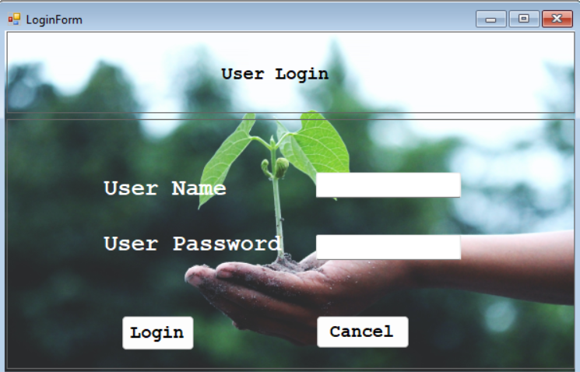
- MAIN FORM

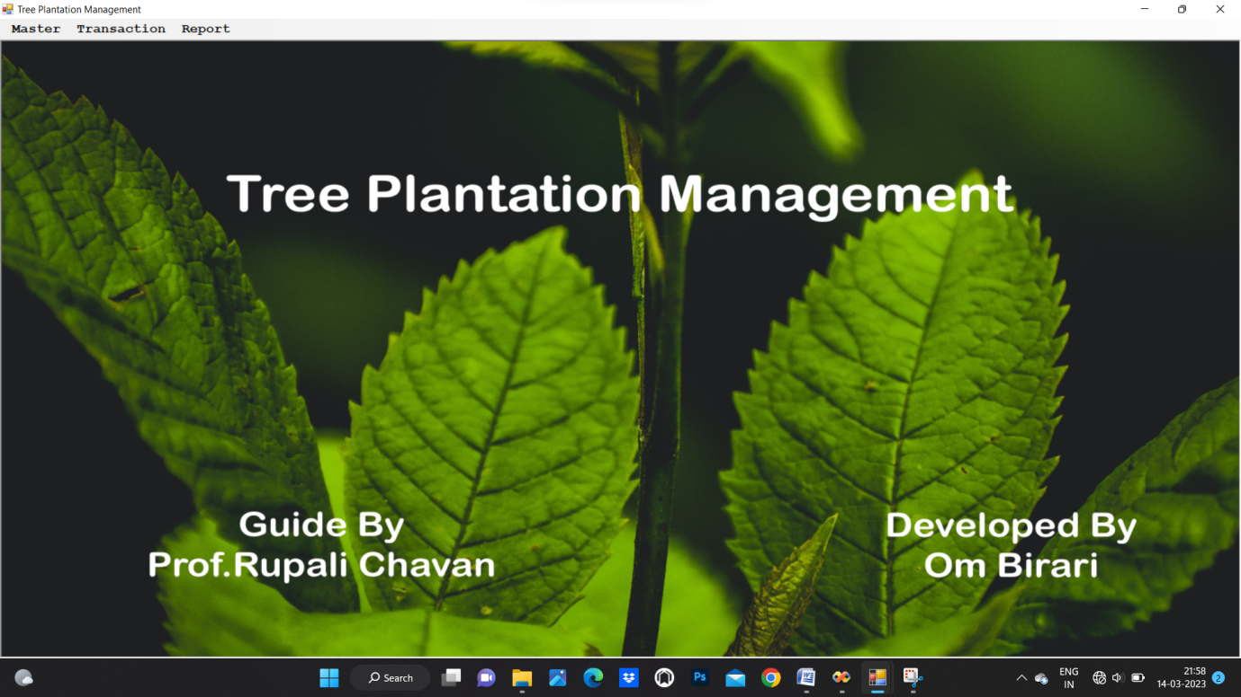

- VOLOUNTER ENTRY
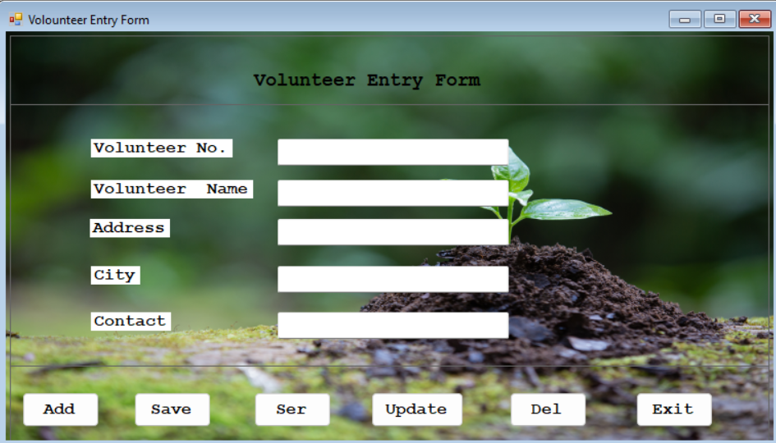
- TREE’S DEATIL ENTRY FORM

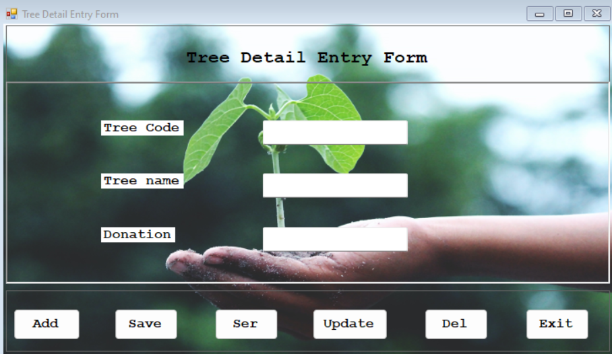

- PAYMENT ENTRY FORM

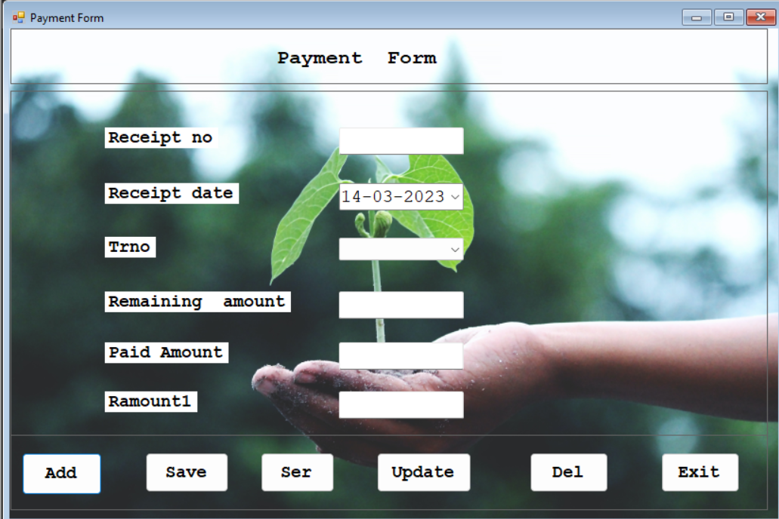
6) TREE’S ESTIMATE ENTRY FORM 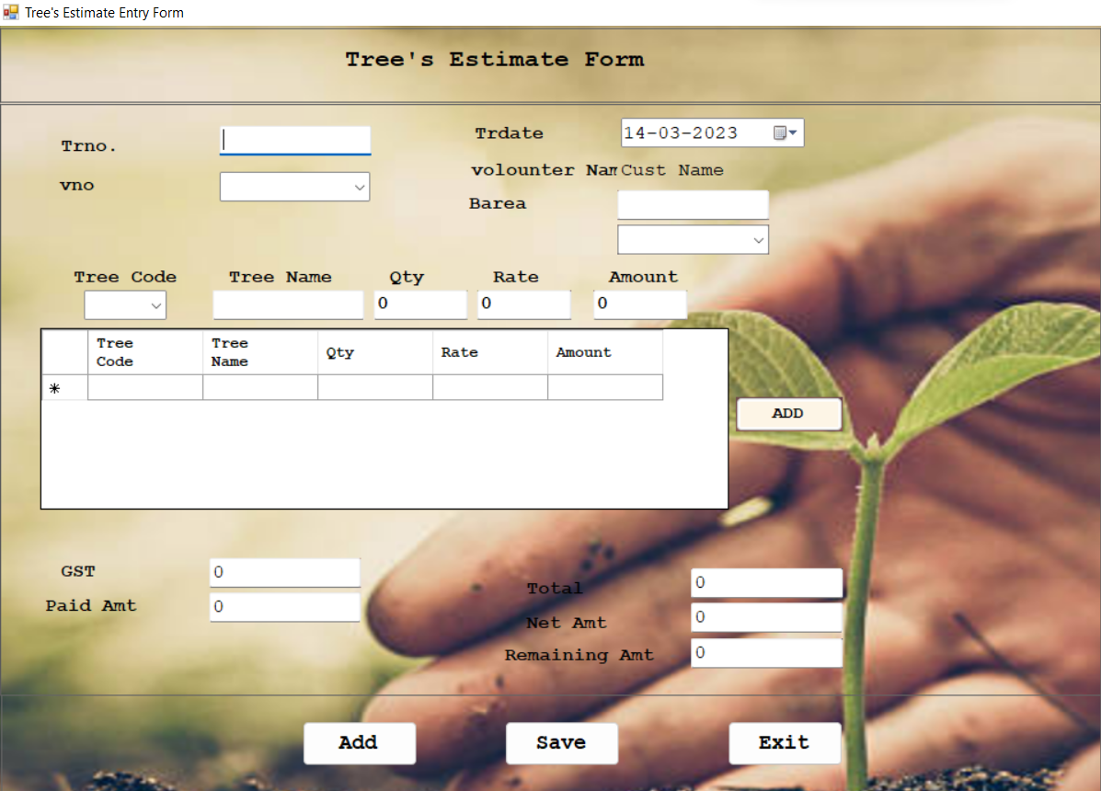
OUTPUT
VOLOUNTER REGISTER
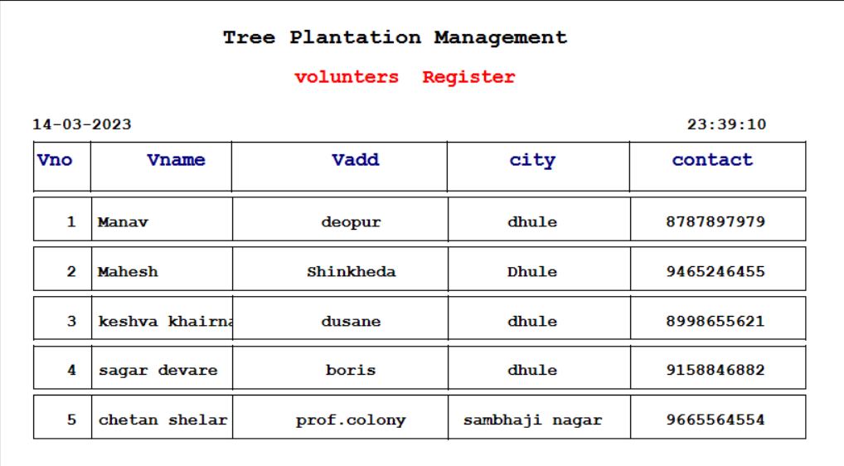

TREE’S REGISTER

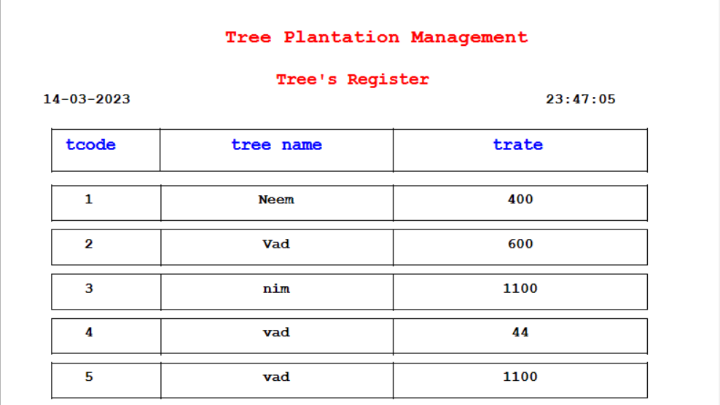
TREES ESTIMATE REGISTER
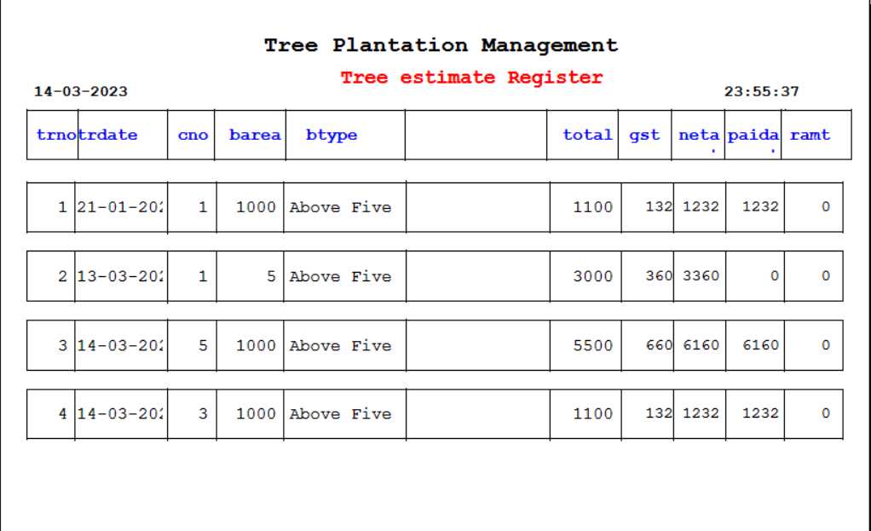

TREES ESTIMATE DETAIL REGISTER

PAYMENT REGISTER
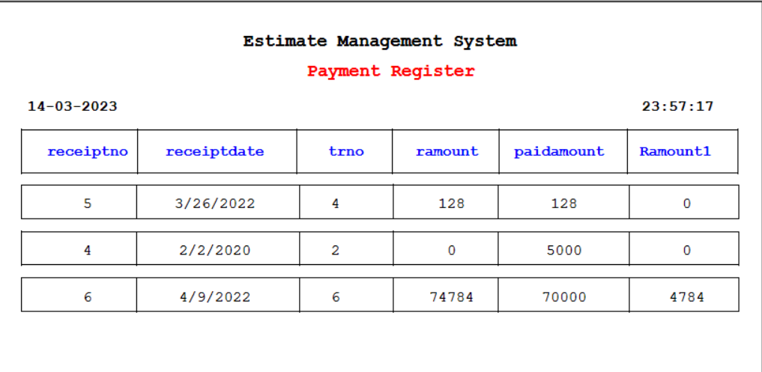
CITY WISE VOLOUNTER REGISTER
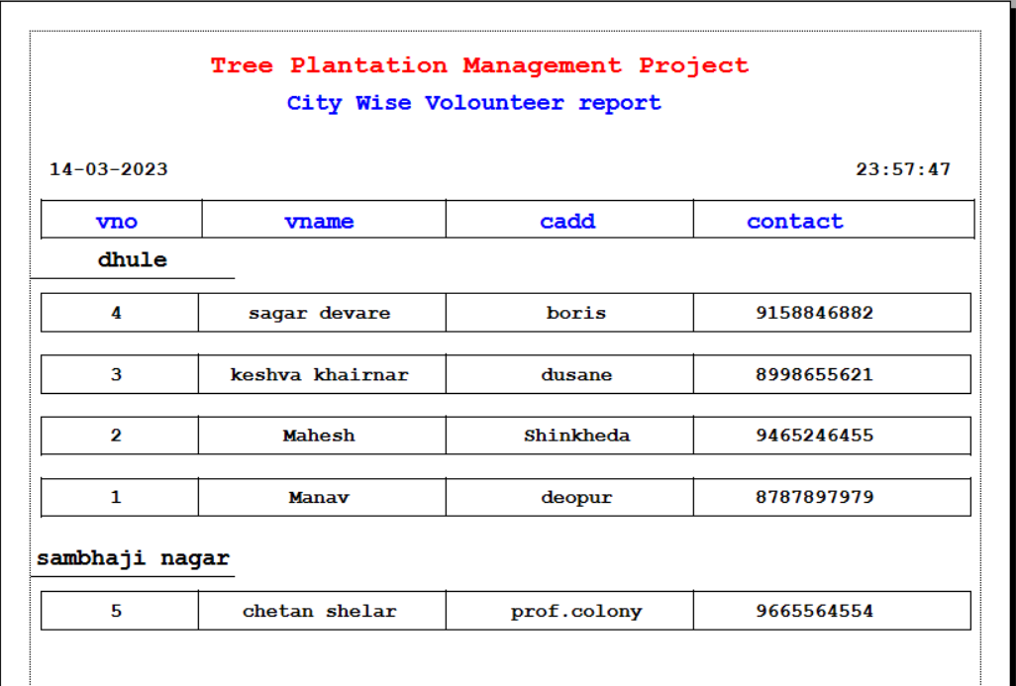

DATE WISE TREES ESTIMATE REGISTER
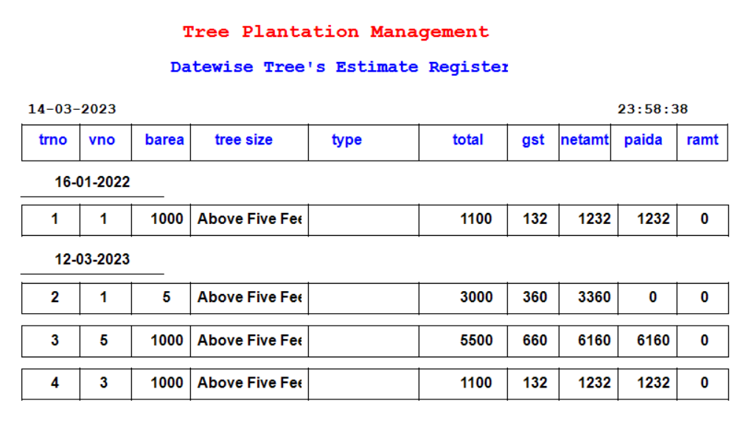
DATE WISE RECEIPT REGISTER
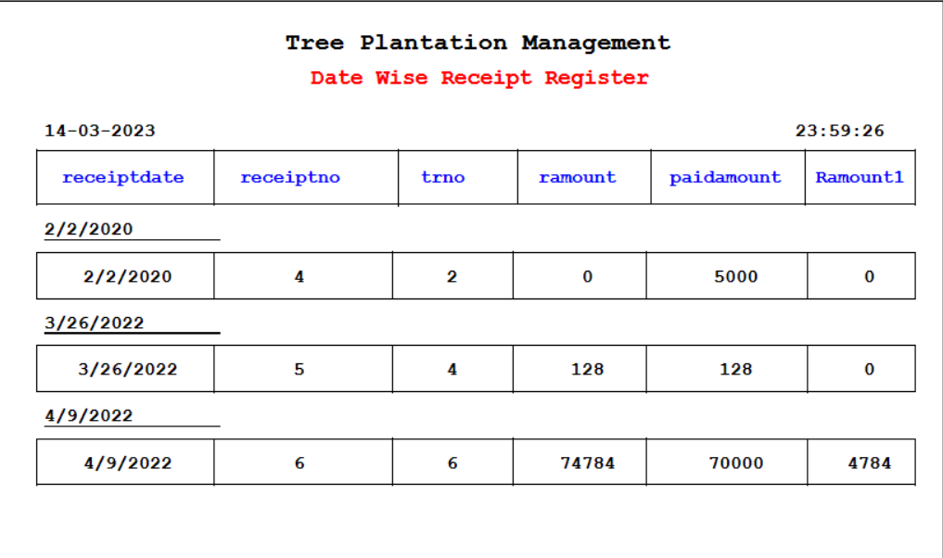
FINAL RECEIPT
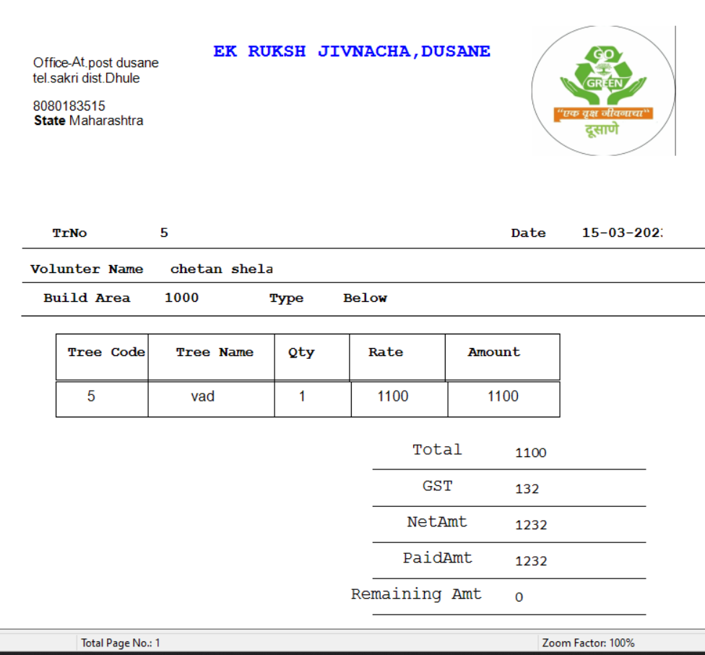
CHAPTER-X
 DATA FLOW 
Data flow diagram
T.M.S

Tree Plantation
Management

Payment
Volounter

Tree
Tree’s Estimate

Zero Level Data Flow Diagram

Bill

Tree Plantation
Management

Tree’s Estimate

Volounter

payment

First Level Data Flow Diagram
BILL
ESTIMATE DETAIL
BILL_MAST
TREE MAST
VOLOT_MAST
VOLOUNTER
BILL
ENTRY
Tree Plantation
Managemet

VOLOUNTER
DETAIL
PROCESS
SCREEN
ENTRY
IF
VALID?
VOLOUNTER
Error
NO
Yes

Fig:- System Flow Chart volot _mast Table.
FIG :- system flow chart TREE Mast Table.
PURCHASE
PROCESS
SCREEN
ENTRY
IF
VALID?
TREE MAST
Error
NO
Yes

CHAPTER-XI
 ENTITY RELATIONSHIP
barea
Trdate
GST
Trno

Has
Tree Estimate
T code
V Name
V No
V Add
T Name

Tree
Has
Volounter
T rate

Has
Has
Tree

Has

Bill
Payment
PaidAmt
RC date
Trno
RCNO
RAmount
CHAPTER-XII
 SYSTEM TESTING 
SYSTEM TESTING:-

System level testing must be conducted prior to installation of any system. It invoices.
1.Preparation of realistic test data in accordance with the system test plan.
2.Processing the test data using the new equipment.
3.Through checking of the result of all system tests.
4.Reviewing the result with future, operators, and of all system personal.
System level testing is an excellent time for training employees in the operation of the new system as well as maintaining it. Typically it requires 25 to 35 percent of the total implementation effort.
One of the most effective ways to perform system level testing is to perform parallel operation consist of feeding both system the same input data comparing the data files and output result. Despite the fact that the individual program were tested, related condition are likely to occur that were not envisioned. Last minute changes to computer programs are necessary to accommodate these new conditions.

CHAPTER-XIII
 LIMITATION OF PACKAGE 
Limitation of package:-
This package is not generalized system. It is useful only for the uses of ‘Tree Plantation Management’ for
“Tree Plantation Management, Dhule”. All the time user have to alert while communicating the package because there are numerous validations checks that can disturb of irritate the new user.

Implementation :-
User manual:-
1.Start the system and run the software application.
2.The menu display as
Master:- It contains the following forms.
1.Volounter Master Form
2.Trees Entry Form
Use these options to store and access the customer and its related transaction data. The “volounter” form allow to enter the personal information of the volounter. It includes volounter number , name , address, city, contact etc. the interface is provided with the required validations.
Transaction:- It contain the following form
- Purchase transaction.
- Bill transaction.

Report :- It contains following report. Click on particular option, you get the report as below-
1. Volounter register.
2.City wise Volounter register.
3.Supplier register.
4.City wise supplier register.
5. Product register.
6.Purchase register.
7.Date wise purchase register.
8.Sales register.
9.Date wise sales register.
Exit:-To exit from the application.
If you have any problem, consult the system administrator.

